**PROJECT NAME – ONLINE HOTEL RESERVATION SYSTEM**

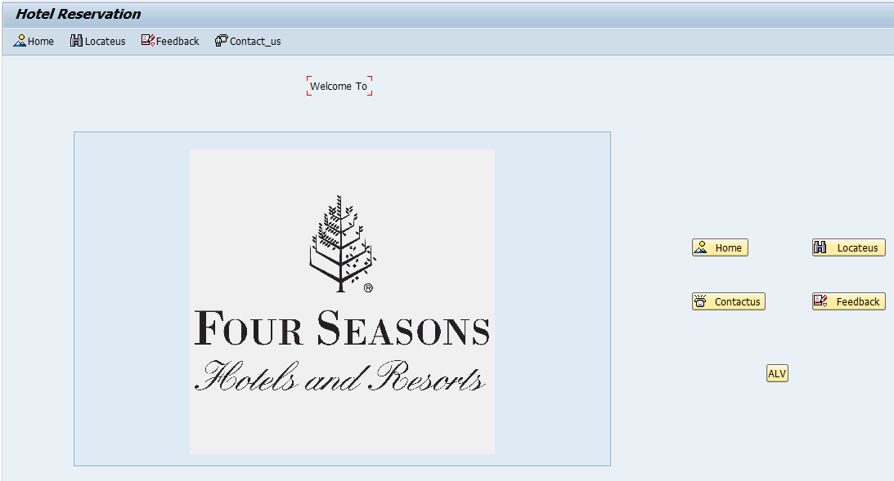

When user press the Locate us push button . It will display the branch locations of our hotel in Maharastra.

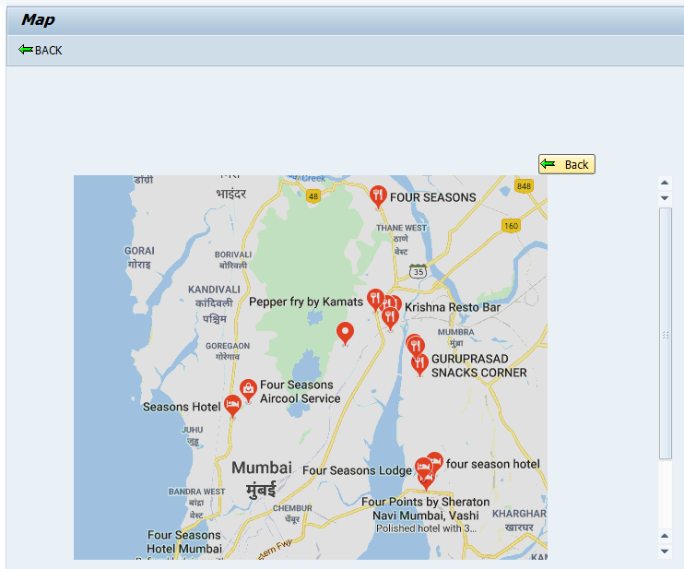

When the user press back push button . it will leave to initial page.

When the user press the contact us push button. It will show the address of our hotel main branch.

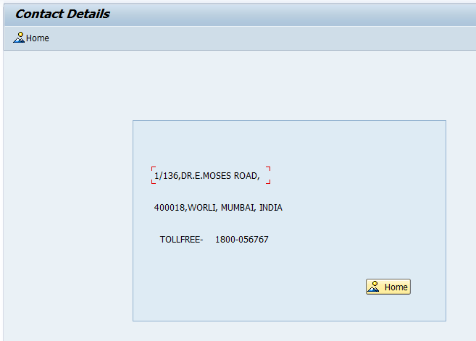

When the user press home push button it will leave to initial page.

When the user press feed back push button. It will leave to feedback page.In feedback page user will give the feedback for our services and the feedback will be stored in a database table.

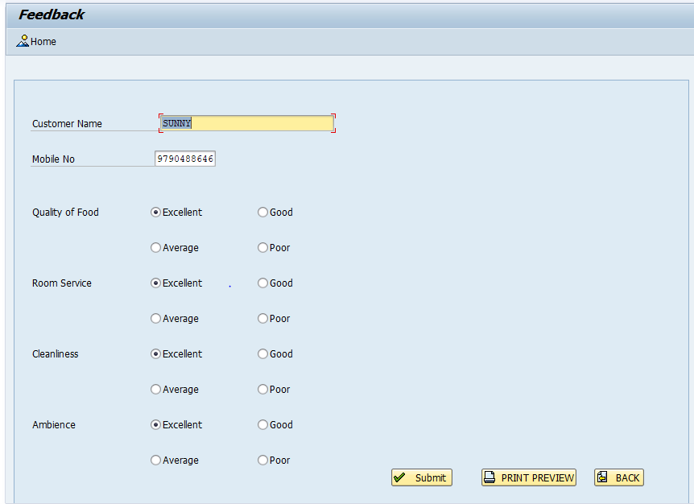

When the admin person will press the print preview pushbutton . An Adobe form will be displayed which contains the details of the customers who filled the feedback form.

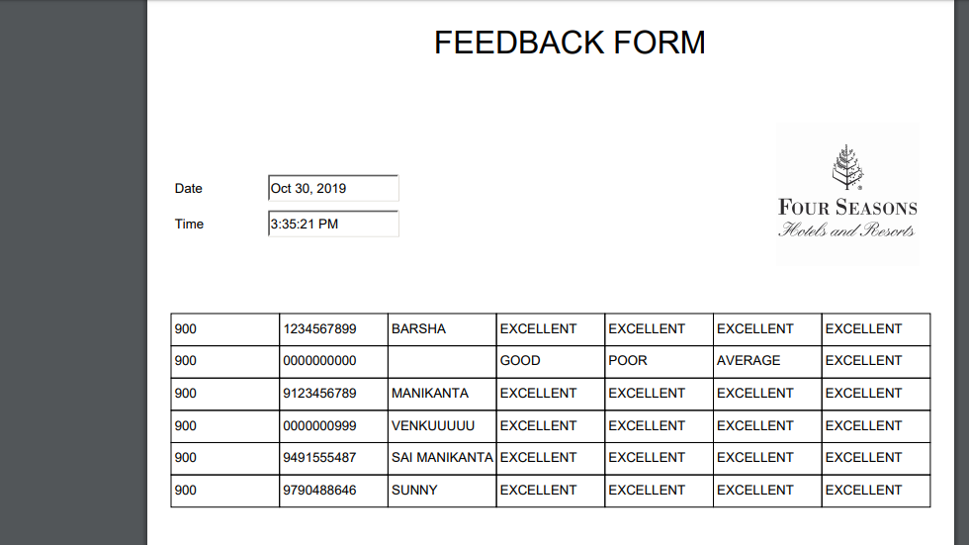

When the admin people press the alv push button. It will display the details of customers.

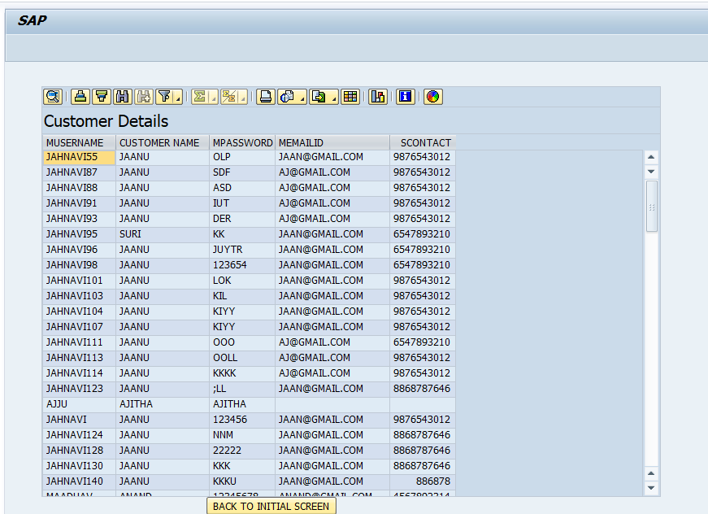

When the admin person press the ‘Back to initial screen’ push button. It will leave to initial screen.